FUNDACIÓN EDUCATIVA DE MONTELÍBANO
LABORATORY GUIDE N°________
NAME_________________________________________________________ CLASS_____________________
GRADE________________

RESPIRATORY AND CIRCULATORY SYSTEMS

THROUGHLINE. How do the respiratory and circulatory system work?

HYPOTHESIS. Why is the heart so close to the lungs?

BACKGROUND INFORMATION

The animal kingdom is full of variety and adaptations for organisms to survive. Respiration, as one of the functions of living things is not an exception. Vertebrates develop in land and water, so evolution took the way to solve the problem by developing respiratory systems adapted to each environment. Animals that live in water have a specialized system that takes the oxygen from the water called Gills. Gills are connected with a network of capillaries in order to make effectively the gas exchange as the animal breathes. Organisms that live on land have lungs. Lungs are bags made of a special spongy tissue that stores air that gets in touch with blood through capillaries surrounding a bag-like structure called alveolus. Remember that respiration is the way our cells obtain energy from glucose in the presence of oxygen and breathing is the mechanical movement to get oxygen into the respiratory system.

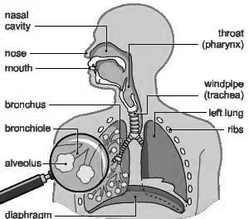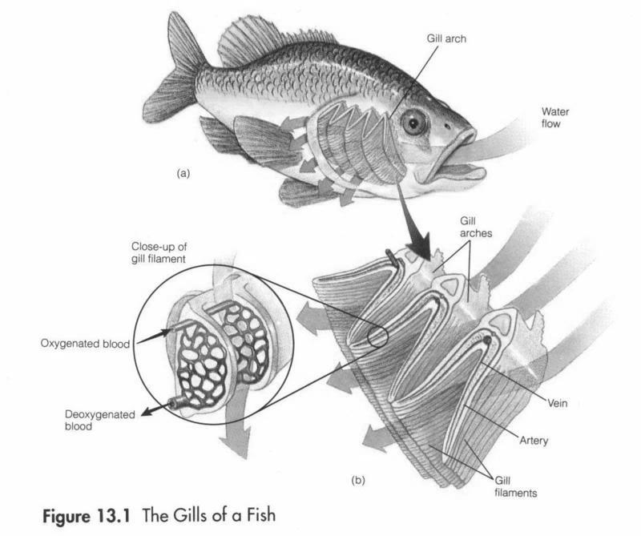

http://www.magazinehealth.com/human-respiratory-system http://www.todayifoundout.com/index.php/2011/09/how-fish-gills-work/

The circulatory system helps vertebrates to transport substances through all the body. It is composed by a network of vessels that connect every tissue of the body. Those vessels are the arteries that move the blood away from the heart, the veins that moves blood to the heart and the capillaries that connect veins and arteries directly from the tissues. The blood is a fluid tissue conformed by a liquid called plasma that carries the different kind of cells of the system. The erythrocytes or red blood cells that carry oxygen to the tissues and removes carbon dioxide from the body, the leukocytes or white blood cells that help on fighting infections and removing dead cells, and the platelets that help forming blood clots in the case of an injury. The heart is the organ that helps moving the blood along the system. It is made of a special kind of muscle that never stops moving so it makes the heart to act like a pumping machine. The heart is connected with the lungs by the pulmonary artery that takes blood there in order to get oxygen from the air and to take it to all the tissues of the body.

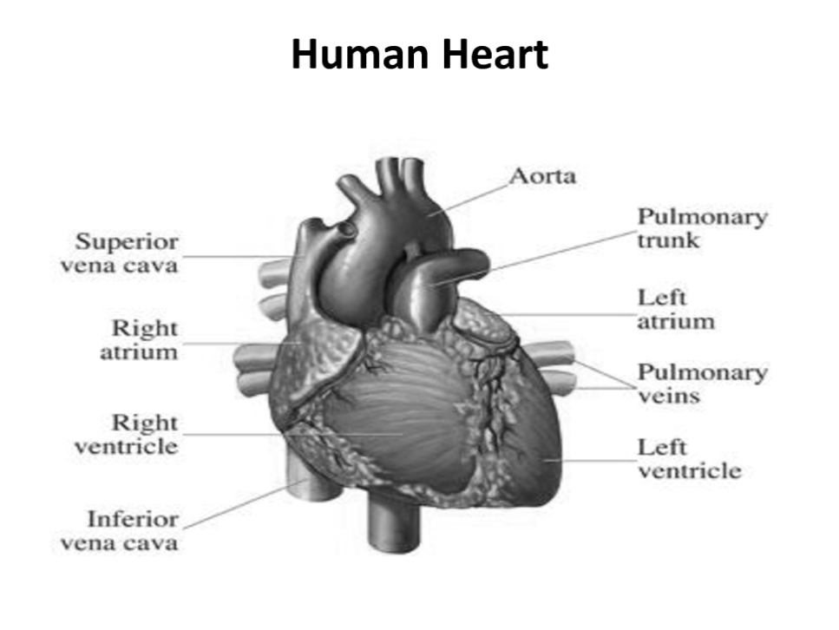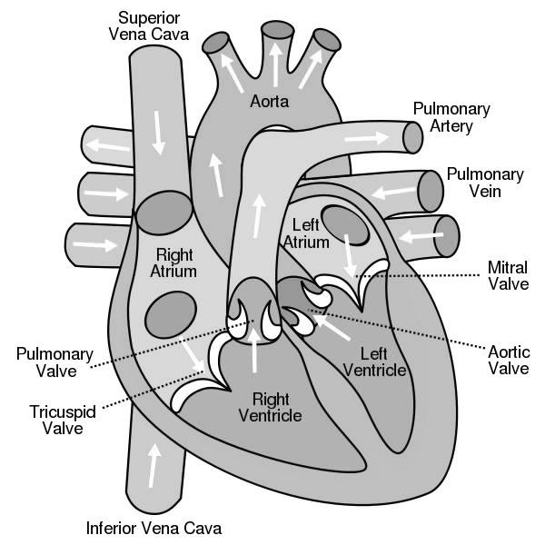

http://www.docstoc.com/docs/80772416/Human-Heart http://www.sciencekids.co.nz/pictures/humanbody/heartdiagram.html

REQUIREMENTS
MATERIALS  A heart of cow or pig  A piece of lung of cow or pig  A fish  Mask  Gloves  A straw | REAGENTS | APPARATUS  Microscopes  Microscope montages of gills and alveoli  A tray with absorbent paper  A blade

SAFETY
 | 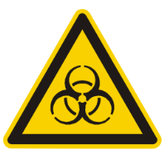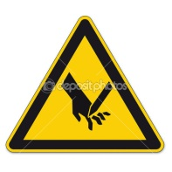

PROCEDURE.
- Put the fish on the tray. Observe the operculum and the disposition of the gills.
- Carefully remove the operculum with the blade and observe the gills. Identify the main parts.
- Remove the gills and observe.
- Observe in the microscope the structure of the filaments of the gills.
- Put the lungs on the tray. Observe the structures and identify the tissues and the pipes.
- Describe the cartilages that make up the pipes.
- Put the straw into a bronchiole, close any entrance of air and carefully blow through it. Be aware of not to aspire air from the lungs. Observe what happens.
- Carefully remove the spongy tissue from the lungs along the bronchi and bronchioles. Observe how they divide as they go through the lung.
- Make drawings with labels and record your observations.
With the heart:
- Put the heart on the tray with the anterior face up; the posterior is flatter. Identify the following parts:
Ventricles, atria, pulmonary and aorta arteries, pulmonary veins and vena cava.
- Introduce your fingers through the arteries and veins and state the cavities they reach.
- Make an incision through the pulmonary artery to the apex. Separate the borders and identify the cavities. Observe the atrioventricular valves and the valves of the arteries. Observe the thickness of the walls.
- Draw your observations, and label the different structures.

CONCLUSIONS

REFERENCES:

AUDESIRK, Teresa and Gerald. Biology, Life on Earth. 11th edition.

http://www.docstoc.com/docs/80772416/Human-Heart

http://www.sciencekids.co.nz/pictures/humanbody/heartdiagram.html
http://www.magazinehealth.com/human-respiratory-system
http://www.todayifoundout.com/index.php/2011/09/how-fish-gills-work/

EXTRA ACTIVITY

- How many lobes do lungs have? Which one is bigger?
- Why do you think trachea is made of cartilage?
- Describe the breathing movement.
- Why do cells need oxygen?
- Why is the left ventricle thicker than the right one?
- Which is the function of the valves?
- Describe the path of a red blood cell throughout the circulatory system from the liver to the lungs, and then to the liver again. What happens to the gases inside of it?

