TRANSPORT THROUGH THE MEMBRANE IN OUR BODY
Observe the following diagrams of metabolic processes. Color each one with the help of your Biology book, then cut and paste each one describing them as passive or active transport. Be specific by writing if it has to be with diffusion, osmosis, facilitated diffusion, active transport, endocytosis or exocytosis.
Muscle contraction  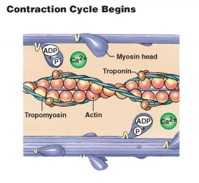 | Sweat glands  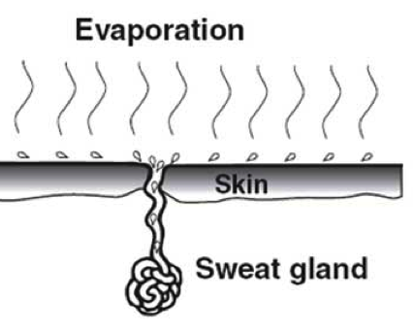
Neurotransmission  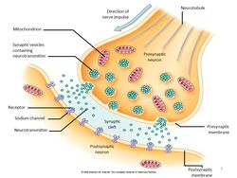 | Gas exchange  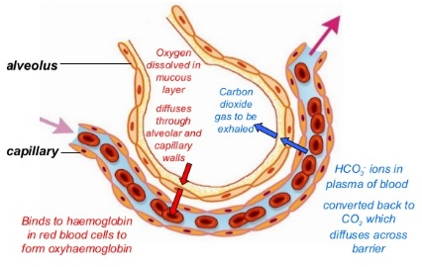
Lymphocytes  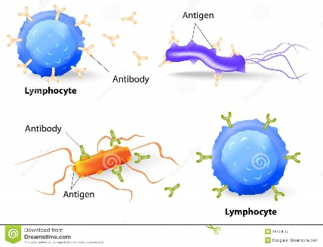 | Digestion  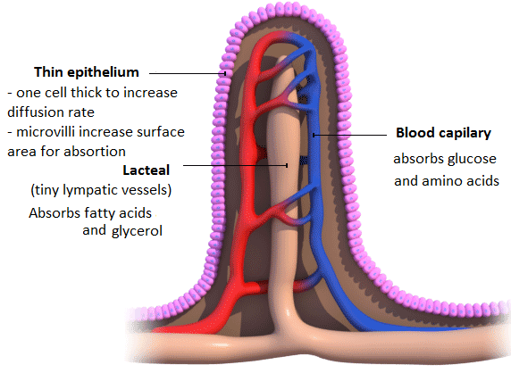
Action potential  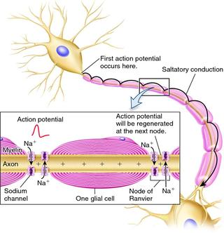 | Phagocytes  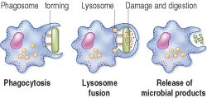
Excretion  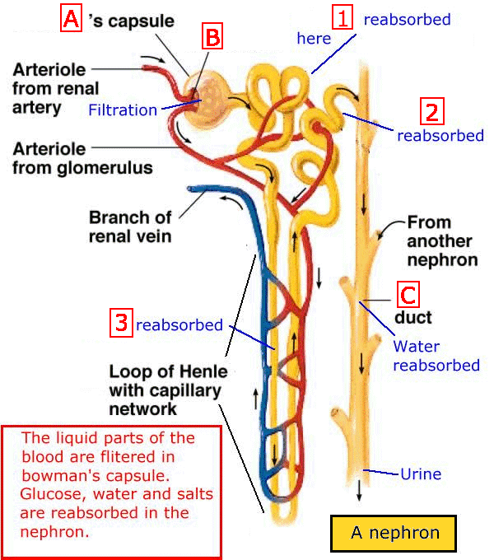 | Secretion of oxytocin  