**NUCLEIC ACIDS**

One of the characteristics of living organisms is to reproduce. Reproduction means to produce healthy offspring to keep the species. Living things use **nucleotides** to replicate themselves. Our chromosomes are made of **Deoxyribonucleic Acid** (DNA) tightly wound, attached to a structural protein called **histone**.

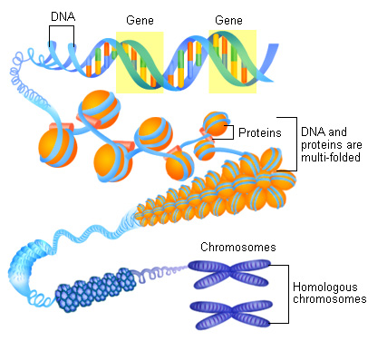

Fig. 1. Structure of a chromosome. <http://activity.ntsec.gov.tw/lifeworld/english/content/gene_cc5.html>

During cell division, DNA replicates itself to make cells with the same traits (genetic characteristics) as the first one. DNA encodes to produce amino acids that bind together to build proteins. To produce proteins, DNA must be copied with the help or **Ribonucleic Acid** (RNA). Nucleotides are substances made of sugar, phosphate and nitrogenous bases or heterocyclic bases that can be classified as Pyrimidines (Molecules with a single ring) and purines (molecules with two rings)

Pyrimidines Purines

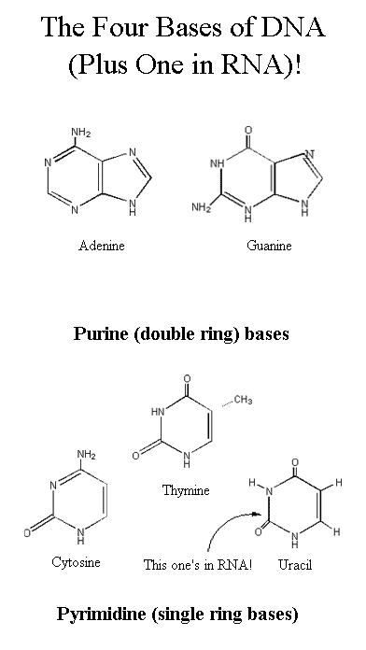 

Fig. 2. Pyrimidines and Purines. <http://deoxyribo-nucleic-acid.blogspot.com/2008_03_12_archive.html>

Those nitrogenous bases are attached to a strand of a 5 carbon sugar called **ribose** for RNA and **deoxyribose** for DNA. Each molecule has a phosphate attached to it.

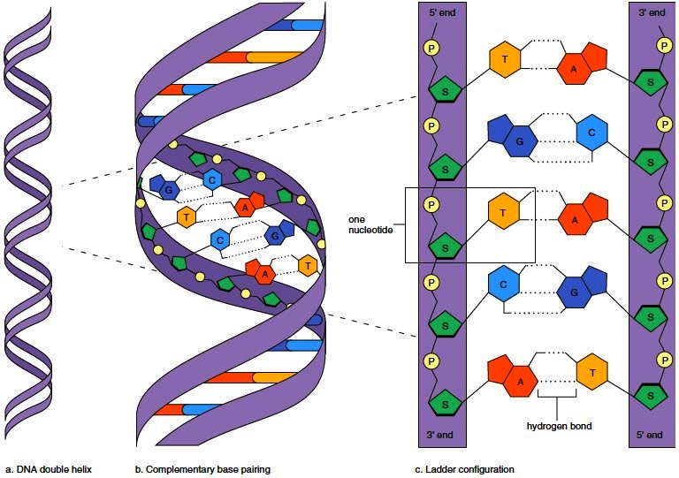

Structure of the DNA molecule (<http://encyclopedia.lubopitko-bg.com/Nucleic_Acids.html>)

As you may see in the drawing, adenine binds to thymine and cytosine binds to guanine.

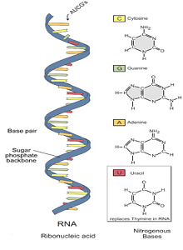

Structure of the RNA molecule (<http://www.1stvs2nd.com/dna-vs-rna/>)

In the RNA molecule, thymine is replaced by uracil.

**ACTIVITY**

Use cardboard and clay of different colors to build up a model of the molecules of DNA and RNA, and the structure of a chromosome.