**FUNDACIÓN EDUCATIVA DE MONTELÍBANO**

**LABORATORY GUIDE N°________**

**NAME________________________________________________ CLASS_________________**

**TOPIC. BIOTECHNOLOGY grade :_________________**

**THROUGHLINE. HOW CAN A PLANT REPRODUCE WITHOUT SEEDS?**

**HYPOTHESIS.**

|  |
| --- |
| **BACKGROUND INFORMATION**  Reproduction is a process by which loving things raise new offspring to preserve species. There are two kinds of reproduction. **Asexual** and **sexual reproduction.** During asexual reproduction, a single organism produces offspring with identical genetic information by simple processes of cell division like mitosis. Because it doesn´t require two mates, it doesn’t involve genetic exchange, so the offspring would be identical to the parent, it means **clones**. Sexual reproduction is carried out by organisms that produce **gametes** or **sexual cells.** Gametes are produced with half the number of chromosomes for the species and then, they fuse in a process called **fertilization** which can happen inside the body of an organism or in the outside. Plants have the ability to reproduce both sexually and asexually. Non-vascular plants produce spores which need to be spread next to a source of water to release the gametes. Vascular plants, like conifers and flowering plants, had developed special structures in which the process of fertilization takes place. Plants also have the ability of producing clones of themselves by growing tissues. It is **vegetative reproduction**. A special tissue in plants called the meristem has the chance to develop into any structure the plant may need to survive. In nature, plants have different structures that can grow into new plants such as **Bulbs** consist of very short stems with closely packed leaves arranged in concentric circles round the stem. These leaves are swollen with stored food e.g. onion. A terminal bud will produce next year’s flowering shoot and the lateral (axillary) buds will produce new plants.  **Corms** also have a short stem but in this case it is the stem itself which swells and stores food. The circular leaves form only papery scales. As with bulbs, the terminal bud grows into a flowering shoot and the lateral buds produce new plants.  **Rhizomes** are stems which grow horizontally under the ground. In some cases the underground stems are swollen with food reserves e.g. iris. The terminal bud turns upwards to produce the flowering shoot and the lateral buds may grow out to form new rhizomes.  **Runners** are also horizontal stems growing from the parent plant, but they grow above ground. When their terminal buds touch the ground they take root and produce new plants. |

|  |  |  |
| --- | --- | --- |
| **REQUIREMENTS** | | |
| **MATERIALS**  1 envelope of unflavored gelatin  1 small piece of a branch of a green plant  1 plastic bowl  1 pot  A spoon  A blade  Plastic gloves  Mask  Tweezers | **REAGENTS**  70% ethanol  15% commercial hypochlorite  Distilled water  Plant fertilizer | **APPARATUS**  1 stove  2 test tubes  1 test tube rack |

|  |  |
| --- | --- |
| **SAFETY** | |
|  | Fragile Sign Clip Art |

|  |
| --- |
| **PROCEDURE.**  Clean up the working area with a solution of 70% ethanol and wash your hands properly.  1. Prepare the unflavored gelatin with half the water indicated in the envelope. Grind with a piece of banana and a spoonful of sugar.  2. Fill up two cm. of the test tube previously sterilized and cover it to avoid contamination.  3. Wash the plantlets in a solution of 10% ethanol during 5 minutes.  4. Wash the plantlets in distilled water and then, with a solution of 15% commercial bleach during 10 minutes.  5. Wash the plantlets in distilled water during 5 minutes.  6. Clean up the tweezers with ethanol before you use them. Take a plantlet and let it dry for a minute. Then, insert it softly in the gelatin as soon as you can.  7. Cover the tubes with vinyl membrane.  8. Put the tubes on the rack close to the light and observe them for a couple of weeks |

**DURING THE EXPERIENCE.**

|  |  |  |  |  |  |  |  |  |  |  |  |  |  |  |  |  |  |  |  |  |  |  |
| --- | --- | --- | --- | --- | --- | --- | --- | --- | --- | --- | --- | --- | --- | --- | --- | --- | --- | --- | --- | --- | --- | --- |
| **OBSERVATIONS (QUALITATIVE & QUANTITATIVE OBSERVATIONS).**  .   |  |  | | --- | --- | | **DAY** | **OBSERVATIONS** | |  |  | |  |  | |  |  | |  |  | |  |  | |  |  | |  |  | |  |  | |  |  | |  |  | |

**AFTER THE EXPERIENCE**

|  |
| --- |
| **DATA PROCESSING**  Make a bar graph with the progress of your plants. |

|  |
| --- |
| **CONCLUSION** |

|  |
| --- |
| **REFERENCES:**  <http://graficas.explora.cl/otros/biotec/salacuna.html>  <http://plantbiotechrtu.wordpress.com/>  <http://www.biology-resources.com/plants-vegetative-reproduction.html> |

**EXTRA ACTIVITY**.

**1** In natural vegetative propagation, which of the following structures are most likely to give rise to new individuals: (a) stems, (b) roots, (c) buds, (d) leaves, (e) flowers?

**2** The drawing shows a plant which reproduces asexually.

(a) What will need to happen before shoots A - C become independent plants?

(b) How might a gardener assist this process?

(c) What name is given to the horizontal stem in this kind of propagation?

(d) Name a commercially grown fruit whose plants are propagated in this way

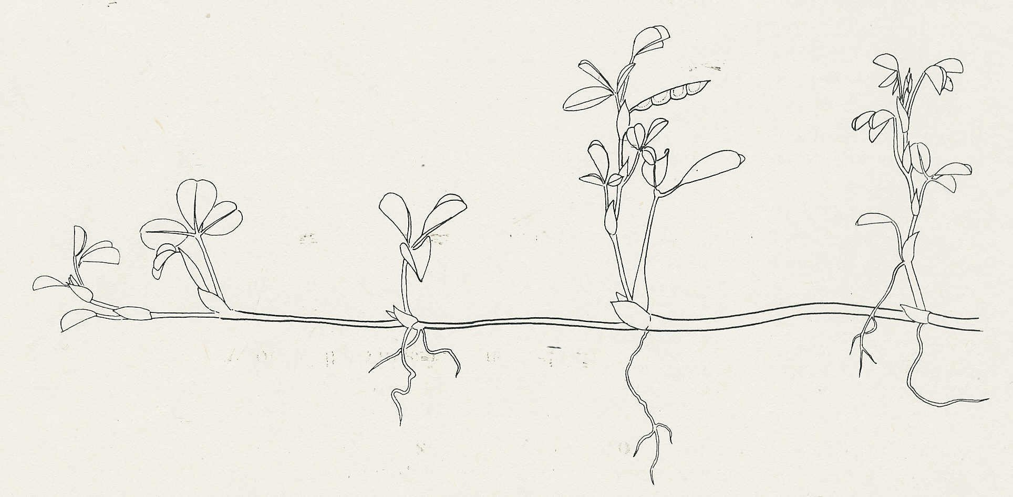

A

C

B

**3** The following are thought to be some of the advantages of either vegetative reproduction or sexual reproduction:

Produces greater variety in the offspring, good at colonizing new areas, reduces competition

from other species, maintains desirable qualities in the offspring, good at colonizing favorable

areas

Make a table with these qualities under the headings of 'Sexual reproduction' and 'Vegetative reproduction'.

**4** If a gardener wanted to propagate a useful variety of apple tree in a way which maintained all its desirable qualities, which of the following techniques would be used:

(a) Planting stem cuttings in potting compost

(b) Grafting stem cuttings onto a root stock

(c) Grafting buds on to a root stock

(d) Growing the seeds produced from the useful variety

(e) Cross-pollinating the variety with another good variety and growing the seeds resulting from the cross?

**5** What name is given to the population of genetically identical offspring which result from a process of asexual (vegetative) reproduction?

**6** Which structures of a flowering plant give rise to (a) potatoes, (b) the fleshy scales of an onion?

**7** In the process of tissue culture in plants, what is needed to induce the formation of a complete plant, in addition to a growth medium with nutrients?