CELL MEMBRANE
- Write the main functions of the cell membrane.

- Color the structure of the membrane according to the key.
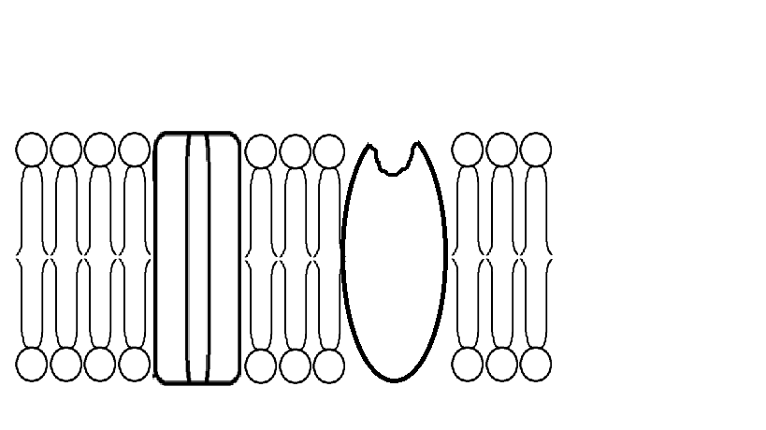
- Phosphoric heads in brown.
- Lipid tails in yellow
- Receptor proteins in purple
- Transport proteins in blue.
- Explain the main characteristic of each part of the cell membrane.
Phosphoric heads:
Lipid tails:
Transport proteins:
Receptor proteins:

- Use the diagram to explain the way substances pass across the membrane.
- Water moves by osmosis across a semipermeable membrane. How has the concentration of the solute changed in the beaker on the right?

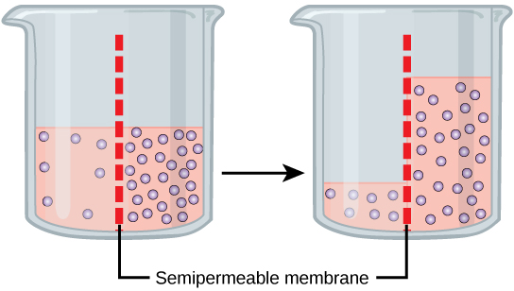

- The cells in the figure depict reactions to the osmotic effects of different solution concentrations. In what direction has the water moved in each of these examples?
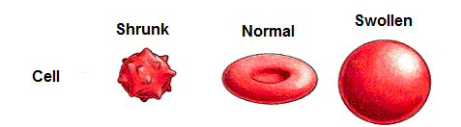

- A perfume is usually spread along a room as it is sprayed. Explain in terms of diffusion, how substances are transported through the phospholipid bilayer and carrier proteins.

- We usually put flowers into water as we cut them. In terms of cell membrane, why is it important to do so?

- The picture shows active transport and bulk transport. How is active transport different from bulk transport?
ACTIVE TRANSPORT | BULK TRANSPORT
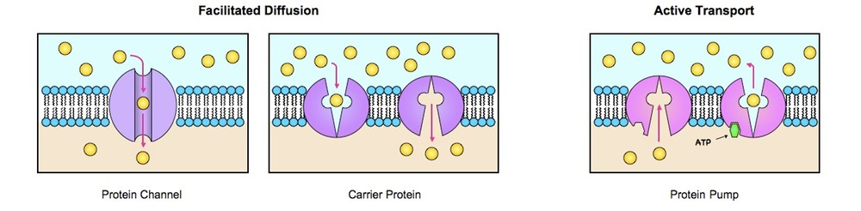 | 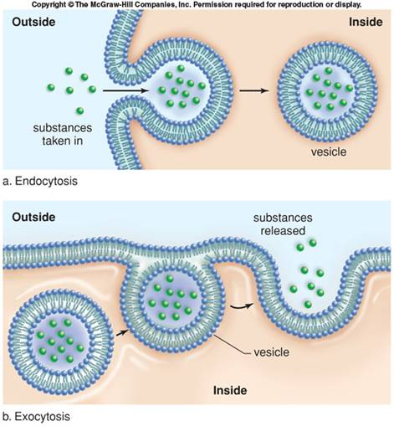

- Relate what you know about ions and explain why is it important to drink isotonic beverages when practicing sports instead of only water. What could happen to your cells if you only drink water during the complete journey?

