NAME: ________________________________________ SUBJECT: Biology
DATE: _____________________ CLASS: _________________ SEMESTER: ____________
ACTIVITY: WORKSHOP. DATA GATHERING Parent signature: ______________________

Statement of Inquiry | Global Context: Identities and relationships
Healthy habits help to maintain systems in balance as we understand how energy works in our body.
Exploration to Develop:
- Physical, psychological and social development
- Transitions
- Health and well-being
- Lifestyle choices
Approaches to learning
• Take effective notes in class
• Reading, writing and using language to gather and communicate information
•Managing time and tasks effectively
• Use appropriate forms of writing for different purposes and audiences
• Create plans to prepare for summative assessments (examinations and performances)
• Gather and organize relevant information to formulate an argument
•Utilizing skills and knowledge in multiple contexts
- Reading, writing and using language to gather and communicate information
• Read critically and for comprehension
• Use and interpret a range of discipline-specific terms and symbols
• Structure information in summaries, essays and reports
Activity: Data collecting and reading comprehension workshop

Terms of instruction:
Recall: Remember or recognize from prior learning experiences
Apply: Use knowledge and understanding in response to a given situation or real circumstances
State: Give a specific name, value or other brief answer without explanation or calculation
Outline: Give a brief account
Interpret: Use knowledge and understanding to recognize trends and draw conclusions from given information
Describe: Give a detailed account or picture of a situation, event, pattern or process
Analyse: Break down in order to bring out the essential elements or structure. To identify parts and relationships, and to interpret information to reach conclusions.
Summarize: Abstract a general theme or major point(s)
Discuss: Offer a considered and balanced review that includes a range of arguments, factors or hypotheses. Opinions or conclusions should be presented clearly and supported by appropriate evidence
Calculate Obtain a numerical answer showing the relevant stages in the working.
Draw Represent by means of a labelled, accurate diagram or graph, using a pencil. A ruler (straight edge) should be used for straight lines.
Estimate Obtain an approximate value for an unknown quantity.
Label Add title, labels or brief explanation(s) to a diagram or graph.

SKILLS: 1. The student gathers information from different sources. 2. The student organizes data and information in charts and graphics. 3. The student states descriptions and explanations from her/his observations.

THROUGHLINE: WHY IS IT IMPORTANT TO CHECK THE NUTRITION FACTS CHART OF THE FOOD WE CONSUME?

BACKGROUND INFORMATION

In order to stay alive and healthy, our body demands a supply of nutrients that play a role in our homeostasis. We are using energy all time, so that is why we need carbohydrates such as sugar and starch. We need to build up cell membranes, and substances such as hormones and steroids. For this we get lipids such as fats and oils. We use proteins to build up and to repair tissues and DNA. We need minerals to help many reactions and cell processes such as neurotransmission, absorption, cell respiration, etc. In other words, to keep our metabolism. Finally, we need vitamins to maintain our body healthy. Water is not a nutrient by itself, but it is very important as a universal solvent to help carry on different chemical reactions. Fiber is not digested, but it helps to sweep away the intestinal contents.

Because we need to get these nutrients, we need to be aware on the proportions of each one, because any deficiency or any excess can cause a serious disorder that can affect our welfare.

We also use to think that calories are some kind of bad substance that we must avoid and reduce. Nothing furthest from the truth. Calories are the units of measurement of energy, so we must be aware on the amount of energy we need during a day, so in that way we can know the number of calories we need in our diet. That is why it is important to consult a nutritionist in order to follow a healthy diet, because according to our age, genetics and habits, it is not so possible to standardize a diet for everybody. A gram of carbohydrates and proteins contain both 4 calories, and a gram of fat contains 9 calories. The average calorie intake is about 2000 to 2500 C per day.

The excess of carbohydrates and fats lead to obesity and circulatory diseases. The excess of proteins can cause kidney disorders, the excess of minerals can cause stones in some glands and organs, and the excess of vitamins can cause malfunctions in some organs, can be toxic, cause uncomfortable reactions such as diarrhea, or allergies. The excess of water can cause hyperhidrosis that leads to the dissolution of electrolytes and therefore the loss of them by sweat and urination generating malfunctions in the electricity of our nervous system. The excess of fiber causes damage in the intestines, so nutrients cannot be properly absorbed, and other diseases can be produced because of irritation.

In the other hand, the lack of carbohydrates can cause laziness and weakness because of the low levels of energy. The lack of fats can cause malfunctions in the nervous system, irritation and damage in some tissues. The lack of proteins can cause weakness, damage in tissues and growth problems. The lack of minerals can cause failure in the metabolism, and the lack of vitamins can cause disease and weakness. The lack of water causes dehydration, so many body functions won’t work properly. The lack of fiber causes constipation which leads to pain and reabsorption of wastes in the long term.

1. ACCORDING TO THE READING, WRITE AN ACCURATE ANSWER TO THE THROUGHLINE.

PROCEDURE:

1. Watch the video “How to Read Nutrition Facts | Food Labels Made Easy” by The Healthy Nerd https://www.youtube.com/watch?v=Orj7p3KQcyQ

2. Observe the following nutrition facts charts.

SPAGHETTI | DELACTOSED MILK | PEANUT BUTTER COOKIES
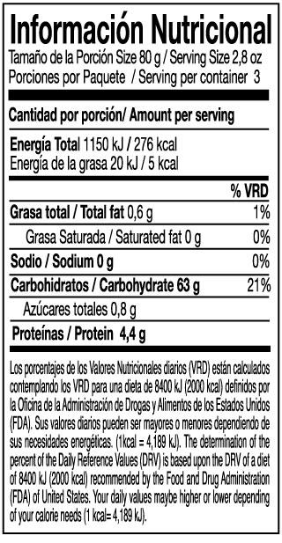 | 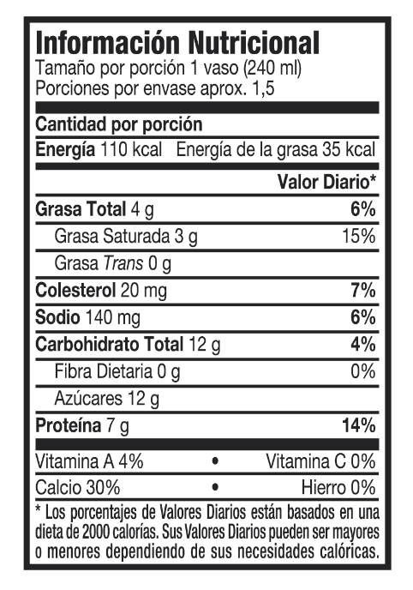 | 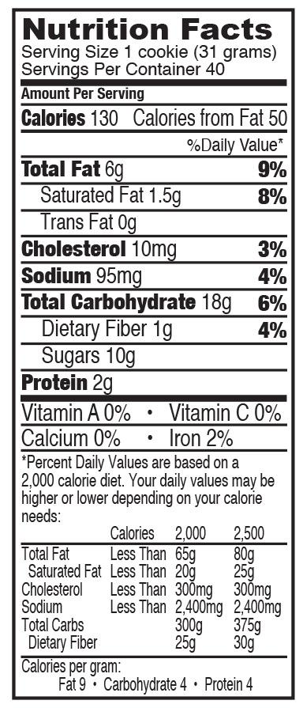

1. Which information is provided by the nutrition chart? Why is it important?

2. Use the information provided to complete a table. Measurements are given in grams and percentage per serving.
FOOD | PROTEINS | CARBOHYDRATES | FATS
SPAGHETTI
DELACTOSED MILK
PEANUT BUTTER

3. Use the information of the tables to plot a bar graph. Don’t forget to write a title for the graph, and to name each variable.

4. Which one contains the highest amount of fat? which one is a good source of proteins? Which one contains the lowest amount of carbohydrates?

5. People usually say, “you should avoid eating calories.” Explain the meaning of this sentence and if it is accurate to say that.

6. Complete the table with the main function of each nutrient.

NUTRIENT | FUNCTION
CARBOHYDRATES
PROTEINS
VITAMINS
LIPIDS (FATS)
MINERALS
WATER
FIBER

7. Explain the sentence “everything in excess is bad” when talking about food.

8. Redpapaz is a Colombian organization of parents that share and make projects in order to improve the conditions of children in schools and within their families. They are asking food industry to include a label or a tag in front of processed food, especially these offered to kids for their snacks, such as chips, packed juices and sodas, and crackers, with the contents of sodium, processed sugars, saturated fats and other ingredients that are said to cause health problems such as obesity, diabetes, and even, cancer. Which is your opinion about this petition? Explain your answer.

