1. TOPIC. USING THE MICROSCOPE

2. THROUGHLINE. How does a microscope work?

3. Competencia Trimestral: Reconocer la estructura de la célula, las funciones básicas de sus componentes y los procesos de división celular importantes en la generación de tejidos.

Establece relaciones causales entre los datos recopilados y saca conclusiones de los experimentos aunque no obtenga los resultados esperados.

4. HYPOTHESIS.

5. BACKGROUND INFORMATION
The microscope is a laboratory device that allows scientists to observe objects that cannot be seen with the naked eye. During history, many strategies had been used in order to observe that mysterious world. It was officially invented by the Dutch Hans and Zacharias Jensen in 1590, when they put a set of lenses in a tube. In 1665, Robert Hooke was a monk that developed a microscope similar to that of the Jansen brothers. With it, he observed a cutting of cork and described his observations as a group of structures distributed as the cells of the monastery in which he lived, introducing for the first time, the word “cell.” In 1674 Anton Van Leewenhoek designed a simple device that allowed him to magnify objects. He could observe tissues and different samples of cells. He was the first person to describe bacteria, and he invented new methods for grinding and polishing microscope lenses that allowed for curvatures providing magnifications of up to 270 diameters, the best available lenses at that time. The microscope had been evolved since so we can easily observe from tissues to molecules according to the kind of microscope we have. Giovanni Amici developed different features since 1827 like the achromatic microscope lens and the oil immersion technique.

6. REQUIREMENTS
MATERIALS  Laboratory coat  A piece of paper  A leaf  A dropper and a blade | REAGENTS  Water | APPARATUS  Electric microscope  Microscope slides and coverslips  A montage of tissue

7. SAFETY
 | 

8. PROCEDURE.

Identify the main parts of the microscope. Be gentle when handling any piece.

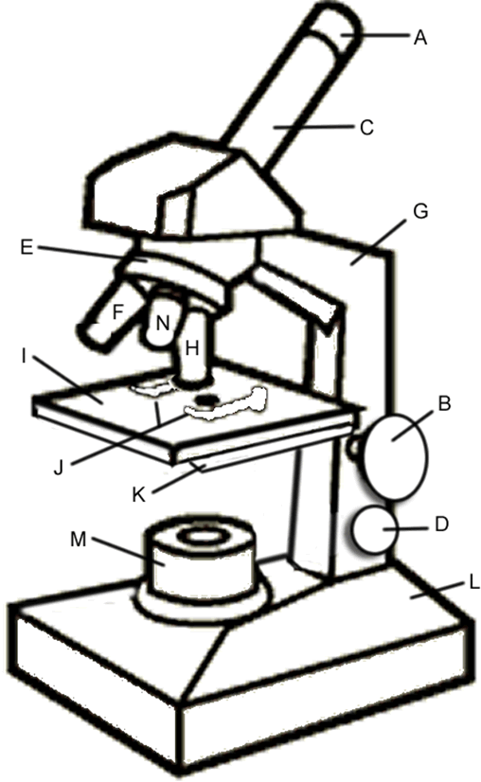

- Cut a letter from your newspaper and put it in a slide. Add a drop of water and cover it with a coverslip. Put it under the microscope.
- Use the revolving piece to see under each objective lens. Draw your observations.
- Use a drop of immersion oil to see under the 100X objective. Draw your observations.

4X | 10X | 40X

- Observe the montage that was given to you and repeat steps 2 and 3.

4X | 10X | 40X

- Carefully, take the blade and make a transversal cutting on the leaf. Put it on a slide, add a drop of water and cover with a coverslip. Repeat steps 2 and 3.

4X | 10X | 40X

- Estimate the size of the objects you saw.

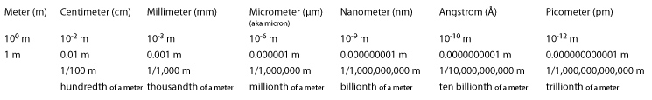

9. OBSERVATIONS (QUALITATIVE & QUANTITATIVE OBSERVATIONS).

10. DATA PROCESSING

11. CONCLUSION

12. REFERENCES:
To learn more, visit:
http://www.sciencelearn.org.nz/Contexts/Exploring-with-Microscopes/Timeline
http://www.bartonmiller.org/Mr._Millers_Fifth_Grade_Class/Atom_files/Timeline%20-%20History%20of%20Microscopes.pdf
http://www.nobelprize.org/educational/physics/microscopes/timeline/ http://inventors.about.com/od/mstartinventions/a/microscopes.htm

13. EXTRA ACTIVITY.

- Make a timeline about the development of the microscope.

- Establish the importance of the microscope for the development of the cell theory and the description of microorganisms and microbiology.

